Race Day

Section A – Entity Relationship Diagram
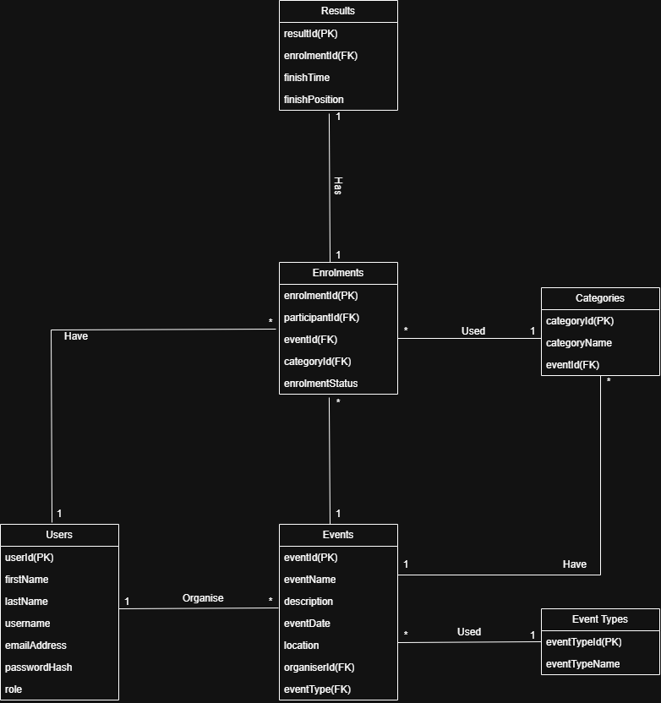

Section B – API Endpoint Plan
Area | HTTP Method | Route | Description | Role Required | Request Body | Expected Response
Authentication | Post |  | Registers new user as either an Organiser or Participent | Public | firstName, lastName,  username, email, password, role | 201 Created – user registered
Authentication | Post | /api/auth/register | Authenticate a user and log them in | Public | Username, password | 200
User Profile | Get |  | View logged in users profile | Authenticated user | None | 200
User Profile | Put |  | Update logged in users profile | Authenticated user | Profile fields | 200
Events | Get |  | Browse all events | Public | None | 200
Events | Get |  | View one events details | Public | None | 200
Events | Post |  | Create new event | Organiser | Event details | 201
Events | Put |  | Update event details | Organiser | Updated event details | 200
Events | Delete |  | Delete an event | Organiser | Eventide | 204
Event Types | Get |  | Get all event types | Participant and Organiser | None | 200
Event Types | Post |  | Add new event types | Organiser | eventTypeName | 201
Event Types | Delete |  | Delete an event type | Delete an Event type | eventTypeId | 204
Categories | Post |  | Add a new category | Organiser | categoryName | 201
Categories | Get |  | Get event categories | Public | None | 200
Categories | Put |  | Update categories | Organiser | categoryName | 200
Categories | Delete |  | Delete category | Organiser | categoryId | 204
Enrolments | Post |  | Enter an event and choose a category | Participant | eventid, categoryName | 201
Enrolments | Get |  | Get own enrolments | Participant | None | 200
Enrolments | Get |  | View event enrolments | Organiser | None | 200
Enrolments | Delete |  | Remove own enrolment | Participant | enrolmentId | 204
Results | Post |  | Capture participant results | Organiser | enrolmentId, finishTime, finishPosition | 201
Results | Get |  | Get own results | Participant | None | 200
Results | Get |  | View event results | Organiser | None | 200

